INTERNATIONAL JOURNAL OF
SCIENCE ARTS AND COMMERCE

Measuring customer based brand equity: Empirical Evidence from the Tourism industry in Sri Lanka

Mrs. K. C. Koththagoda
Department of Marketing Management
Faculty of Commerce & Management Studies
University of Kelaniya,
___________________________________

Abstract

Branding literature emerged during the 1940s, and academic researches related to destination branding is a relatively new marketing concept for the tourism industry, it remains a lack of theory in particular that addresses the measurement of the effectiveness of destination branding over time. This study is to examine the practicality and applications of a customer-based brand equity model in the Tourism Industry in Sri Lanka. In this study based on Keller’s constructs of the pyramid of brand equity, including brand salience, brand performance, brand imagery, brand judgments, brand feelings, and brand resonance, are investigated and their relations with brand equity . The present study used a sample size of 385 those who have visited Sri Lanka as a tourist and simple random sampling techniques were used to select the individuals from the population. The data were collected by administering questionnaire. The research hypotheses were tested through Structural Equation Modeling and the final model was confirmed. The findings of the study revealed that only the relationships between brand imagery and brand equity were not significant, and all other relationships were significant. Also, fit indices obtained for the conceptual model refer to the high validity of the model in explaining the relations among variables towards tourism industry.
KEY WORDS: Brand Equity, Tourism Industry, Destination Branding, Structural Equation Modeling

Introduction
Brand equity is regarded as a very important concept in business practice as well as in academic research because marketers can gain competitive advantage through successful brands. The study on brand equity is becoming increasingly popular and important academic contributors throughout the 1990s were Aaker (1991), Srivastava and Shocker (1991), Kapferer (1992), and Keller (1993, 1998). Almost all conceptualizations of brand equity agree today that the phenomena involve the value added to a product by consumers’ associations and perceptions of a particular brand name (Winters 1991, Chaudhuri 2001). High brand equity levels are known to lead to higher consumer preferences and purchase intentions (Cobb-Walgren et al., 1995) as well as higher stock returns (Aaker and Jacobson, 1994). Tourist destinations also benefit from concerted branding strategies (Kemp et al., 2012).
Because in today world of tourism, traveling to distant vacation destinations is increasingly popular. As a result, the competition between destinations to attract more tourists is intensifying. In order to enhance their tourism revenues, destinations must develop effective destination branding strategies to stand out in potential tourists’ minds as viable choice possibilities. Because of the competition among tourism industry branding has become an important element of destination management. Although the branding literature commenced during the 1940s (Guest, 1942) the first journal articles related to tourism destination branding did not emerge until 1998. (Pritchard and Morgan, 1998). While much progress has been made in the past few years (Konecnik and Go, 2008; Hudson and Ritchie, 2009; Hankinson, 2009), this field remains in its infancy.
Since the 1990s there has been a growing interest in the concept of customer-based brand equity (CBBE) for firms (Aaker, 1991). Based on the CBBE model Konecnik and Gartner (2007) have investigated the different dimensions of customer-based brand equity for a tourism destination (CBBETD).Within the tourism literature there are few studies have applied customer based brand equity models for destination branding.
Hence this study based on Keller’s (2008) brand equity model which includes six factors of brand salience, brand performance, brandimagery, brand judgments, brand feelings, and brand resonance view point of the customer. To promote a destination, it should be meaningful to the customer. Therefore the basic assumption of Keller’s model is that the power of a brand is what the customer feels, sees, and hears about the brand through experiencing it over time. In other words, the power of a brand is inherent in what is in the minds of customers. This study examines the components of customer based brand equity model empirically with relate to the Tourism Industry in Sri Lanka.

Problem Sataement
Being a developing country with ample of natural resources, Sri Lanka could be benefited through promoting tourism while adding value to the industry adapting destination marketing strategies. The main discouraging situation related to tourism industry in Sri Lanka is the huge literature gap of literatures related to destination marketing in Sri Lanka. That implies is a huge gap in empirically and theoretically to promot Sri Lanka as a tourism destinations. In this context this will address these research gap through destination marketing stratergies. Under the destination marketing concept, destination branding plays a significant role in creating and add value to the destination, hence brand equity can be used as a method for achieving competitive advantage Brand equity is typically considered as the measure of the power of the brand, which provides the assessment of the past marketing efforts’ effectiveness, evaluates the success of brand positioning, and predicts the future brand performance (Aaker, 1991, 1996; Keller, 1993, 2003). Based on this concept policy makers should pay their attention to promote Sri Lanka as tourism destinations. Therefore this study is to determine what the role of Keller’s (2008) brand equity model is and how it can be managed to promote Sri Lanka as a tourism destination.

Literature Review
In the last two decades, brand equity has become the most interesting research topic in marketing for both academics and practitioners. Despite the fact that brand equity is a potentially important marketing concept. It is because brand equity is defined in different ways for different purposes (Keller, 1998). Brand equity is the most common tool used to represent brand performance (Pike, 2010, p.124) as it represents the added or subtracted value a brand gives to products or services (Aaker, 1996, p.7-8) and as such brand equity should reflect “the way customers think, feel, and act with respect to the brand”(Kotler and Keller, 2011, p.243).
The literature suggests that there have been two primary perspectives relating to studying brand equity (Keller, 1993). The first approach is motivated by financial outcome for the firms. With this perspective, the brand is evaluated financially for accounting purpose and is usually manifested in the balance sheet. The second approach is based on the customer-brand relationship. There have been also debates on the importance of brand equity for products and services. Some researchers argue that branding (and thereby brand equity) is more important for services due to the intangible nature and the so-called ‘credence’ attributes of services, which makes it difficult for customers to examine the content and quality of a service before, during and even after the consumption of the service (Krishnan and Hartline, 2001). Aaker (1991) stated that the assets and liabilities linked to a brand’s name or symbol can be grouped into five dimensions: brand loyalty, brand awareness, perceived quality, brand associations, and other proprietary brand assets. He suggested that we can generate brand equity by strengthening those dimensions.
Today, the CBBE model is a well‐established marketing concept (Aaker, 1991, 1996; Keller, 1993, 2001). Keller (2008, 2009) extends the CBBE model in order to address the consumer knowledge structure behind the brand development and to reflect the relationship building process between customers and the brand. Specifically, the model reflects the CBBE pyramid (i.e. hierarchy) consisting of six brand building blocks corresponding to four stages of brand development. Keller (1998), who approached the concept of brand equity from the perspective of the consumer, defined “customer-based brand equity as the differential effect that brand knowledge has on the consumer or how customers respond to the marketing of that brand.” He also suggested that as customers respond more favorably to a product whose brand is identified, the brand has positive customer-based brand equity and it exists when the consumer has a high level of awareness and familiarity and strong, favorable, and unique brand associations in their memory (Keller, 2001). The brand is established through the proper identity, the appropriate brand meaning, the right brand responses, and the appropriate brand relationships with customers by establishing six core brand values: brand salience, brand performance, brand imagery, brand judgments, brand feelings, and brand resonance (Keller, 2001). The strongest brands do extremely well in all six of these areas and therefore achieve all four of the steps concerning building a brand. The top of the pyramid, consumer brand resonance, is considered the most valuable building block. This can only occur when all the other blocks are synchronized to fit the customers‟ needs and desires. A high consumer brand resonance means customers feel a loyalty towards the brand and continuously seek opportunities to interact with the brand and share this with others (Keller, 2001). The basic idea of the CBBE-model is that the measure of the strength of a brand depends on how consumers feel, think, and act with respect to that brand. To achieve consumer brand resonance a brand first needs to elicit the proper emotional reactions from consumers and to elicit the proper emotional reactions there must be an appropriate brand identity and the right meaning. The right meaning and identity can make the customers consider this product as relevant and their kind of product. The strongest brands make consumers feel so attached to the brand that they in fact become “spokesmen” for the brand (Keller, 2001). Further this model describes that a brand’s power and value to the corporation is determined by the customers. Through deeper learning and experiences with a brand the customers end up thinking and acting in a way that allows the corporation to obtain the advantages of brand equity. The model states that even though marketers play a huge part and need to design the most effectivebrand-building programs possible, the success of those marketing efforts ultimately depends on customers‟ responses.
Conceptual framework and Hypotheses
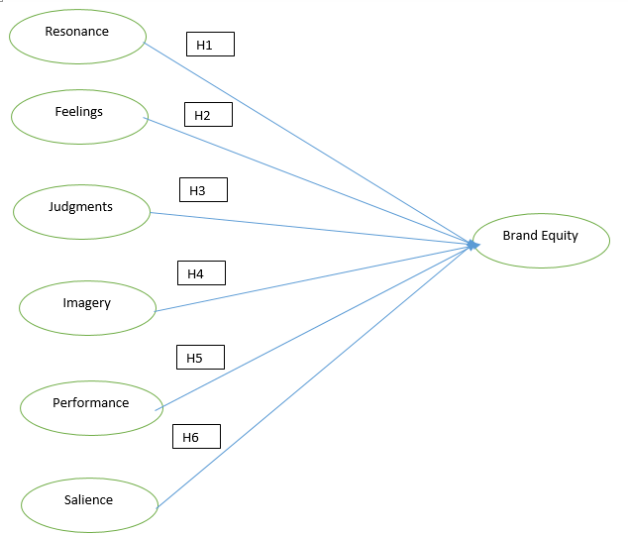
When consider successful brand management it is very much essential to have sound understanding about customer based brand equity. As Keller (1993) explains, positive customer-based brand equity can lead to greater revenue, lower cost, and higher profit; it has direct implications for the firm’s ability to command higher prices, a customer’s willingness to seek out new distribution channels, the effectiveness of marketing communications. This study propose associative relationships among the six CBBE dimensions of Keller’s brand equity model of brand Salience, brand performance, brand feelings, brand judgments, brand image and brand resonance and sets out to retest the measurement of customer-based brand equity in tourism industry in Sri Lanka. Keller (2008) brand equity model has based to develop the conceptual framework of this study and it was extracted from the litretutre (Abdoli; Dalvi and Karimkhani, 2012). This conceptual frameaork is presented in Figure 2.1.

Figure 2.1: Conceptual Framework
Hypotheses
H1 :Brand resonances has a significant positive direct effect on brand equity.
H2: Brand feelings has a significant positive direct effect on brand equity.
H3: Brand judgment has a significant positive direct effect on brand equity.
H4: Brand imagery has a significant positive direct effect on brand equity.
H5: Brand performance has a significant positive direct effect on brand equity.
H6: Brand salience has a significant positive direct effect on brand equity.
Methodology
Sample and data collection
Due to large size of the population data were collected from the sample and sample size was defined using Cochran’s formula. According to the calculation sample size was 385 and individauls were selected to the sample from using a simple random sampling technique the the tourists who have visited recreational sites in Sri Lanka.

N= Z ² x pq
€ ²

n: Sample size
P: Percentage of trait distribution in the population
q: Percentage of members lacking the trait
(it must be mentioned that p and q were unspecified, it was assumed that p=q=0.05, in which case the value of n would be maximum).
Z: level of significance which 1.96 is in this study
€: it is he error amount that in this research like all other social sciences researches, it was considered to be 0.05.
(1.96) (1.96) (0.5) (0.5)/ (0.05)(0.05) ≈385
The sample size of 385 was obtained. Since it was expected that some questionnaires would not be returned, 400 questionnaires were administered.

Operationalizations
Table3.1 operationalization of the variables
Variables | Sub dimensions | Indicators | Number of items for measuring the construct
Brand Salience | Category identification  Need satisfaction | Recognize  Recall | Q10 – Q 13
Brand  Performance | Primary characteristics and secondary features  Product reliability, durability, and serviceability  Service effectiveness, efficiency, and  Empathy  Style and design  Price | Dose this brand provide the basic functions of the product or service category  Dose this brand satisfy the basic needs of the product or category  To what extent does this brand have special features  How reliable  How effective is this service  How efficient is this service  How friendly and courteous is this service  How stylish  How reasonable | Q14 – Q26
Brand Imagery | User profile  Purchase and Usage  Personality and Value  History, Heritage and Experience | To what extent do people admire and respect use this brand  How much do you like people who use this brand  How well do following words describe this brand ( regarding the personality of destination)  To what extent does this brand bring back pleasant memories | Q26- Q34
Brand Judgment | Brand quality  Brand credibility  Brand consideration  Brand superiority | What is your overall opinion of this brand  What is your assessment of the product quality of this brand  To what extent dose this brand fully satisfy your product needs  Dose this brand offer good value  How knowledgeable are the makers of this brand  How innovative are the makers of this brand  To what extent do the makers of this brand understand your needs  How much do you like this brand  Which is your favorite brand  How unique is this brand  To what extent does this brand offer advantages that other brands cannot | Q35- Q45
Brand Feelings | Warmth  Fun  Excitement  Security  Social approval  Self respect | Dose this brand give you a feeling of  Warmth  Dose this brand give you a feeling of fun  Dose this brand give you a feeling of excitement  Dose this brand give you a feeling of security  Dose this brand give you a feeling of social approval  Dose this brand give you a feeling of self respect | Q46 –Q49
Brand Resonance | Loyalty  Attachment  Community  Engagement | I buy this brand whenever I can  I feel this is the only brand of this product I need  I really love this brand  This brand is special to me  I really identify with people who use this brand  I feel I almost belong to club with other users of this brand  I really like to talk about this brand with others  I am always interest to learn more about this brand  I am proud to have others know I use this brand  Compared to other people, I closely follow news about this brand | Q50 –Q59
Brand Equity |  | Even if another brand has the same price as my brand, I would still buy my preferred brand  Even if another brand is similar to my brand, it still seems smarter to purchase my brand  Using my brand adds value to my experience | Q60–Q62

Validity
To evaluate the validity of these seven variables in measuring a principal component factor analysis with varimax rotation was performed. The Kaiser-Meyer-Olkin (KMO) test statistic of for the sampling adequacy to perform a factor analysis and Bartlett's test of sphericity for indicate the correlated measured items. Decision making value for the Kaiser-Meyer-Olkin (KMO) should be greater than 0.5 for the satisfactory analysis to proceed and all the variables have been satisfied this requirement this values are represented in (table3.2). From the same table indicate the Bartlett's test of sphericity is significant that is, its associated probability is less than 0.05 and component matrix which was accepted which is higher than 0.3.
Table 3.2 : Results of the Validity Test
Variable | Kaiser-Meyer-Olkin (KMO) | Bartlett's test of sphericity  P=0.000
3Salience | 0.756 | 274.739
Performance | 0.944 | 1472.757
Imagery | 0.888 | 731.707
Judgment | 0.931 | 1213.349
Feelings | 0.734 | 257.138
Resonance | 0.914 | 1018.563
Brand Equity | 0.672 | 202.586

Reliability
Reliability analysis measures how consistent results are yielded over time and across situations. It has two dimensions: repeatability and internal consistency. Cronbach’s alpha was applied to establish reliability (Zikmund, 2003). Cronbach’s alpha provides the estimate of the degree of the inter-correlations among the items (Churchill, 1995; Nunnally, 1978). Reliability test was performed for all the 385 questionnaires using SPSS for this study. The least value acceptable for the reliability of the items was 0.7. The alpha coefficient was calculated for each item. The results obtained refer to high reliability of the questionnaires as presented in (table3.3).
Table 3.3 : Results of the Relability Test
Variable | Cronbach’s alpha of the sample | Number of items for measuring the construct
Salience | 0.870 | 03
Performance | 0.852 | 12
Imagery | 0.780 | 07
Judgment | 0.878 | 10
Feelings | 0.757 | 03
Resonance | 0.890 | 09
Brand Equity | 0.745 | 03

Results
The survey was carried out with a sample of three hundred and eighty five. In the survey questionnaire many demographical data was collected such Gender, Marital status, Age, Educational level, Profession, Income, etc. Almost 65% of the respondents were male and almost 72% of the respondents were single in marital status. Almost 80% of the tourists were in the age range of 18 to 35 years and almost 51% of the respondents were with diploma or certificate level in education. Almost 70% of the respondents were technical or managerial in occupation and almost 64% of respondents have a monthly income more than USD4000.
Checking normality
For the normality check it develop two following hypothesis and if significant value is above 0.05, we could accept the null hypothesis, that is distribution is normal.
H0: The relevant variable is normal.
H1: The relevant variable is not normal.
As per the definition of the Kolmogorov-Smirnov test, this test is using only for the sample size is more than 2000. Since the sample size is 385 in this study we only consider the values of Shapiro Wilk test. Shapiro-Wilk test are below 0.1 and significant values are above 0.05 in both cases. Hence null hypothesis is accepted and data are assumed to be normally distributed.
The Structural Model of the Study
Table 4.1 : Hypothesis testing
Direct effect |  |  | Standard Estimate | P-value | Rejection or confirmation of the hypothesis
Brand Equity | <--- | Salience | 0.150 | 0.011 | Confirmation
Brand Equity | <--- | Performance | 0.110 | 0.038 | Confirmation
Brand Equity | <--- | Imagery | 0.070 | 0.155 | Rejection
Brand Equity | <--- | Judgment | 0.270 | 0.006 | Confirmation
Brand Equity | <--- | Feelings | 0.170 | 0.007 | Confirmation
Brand Equity | <--- | Resonance | 0.220 | 0.007 | Confirmation

As the results of path analysis in table 4.1 indicate, brand salience, brand judgment, brand feeling, brand resonance are significant affected on brand equity with respect to the acceptance criteria of standard estimation above 0.1 and P value below 0.05. But results reflect that brand performance and brand imagery are not significantly affected on brand equity since standard estimation is below0.1 and P value higher than 0.05. Summary of the Structural equation model is show with Figures 4.1and 4.2 presenting P-values and Standard estimation respectively. 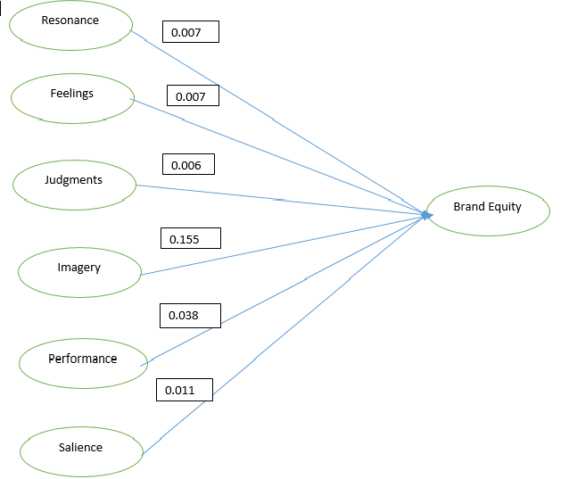
Figures 4. 1 : P- Values
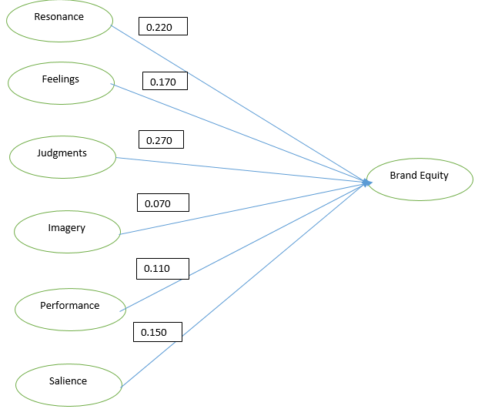
Figures 4. 2: Standard estimations
Chi square index: X2 index is 0.000 as per the definition and chi square measures the difference between the saturated model and theoretical model. Saturated model is the model with all the possible paths to be analysed and being saturated model is the best fitness of a theoretical model.
For a saturated model chi square is zero and in this study chi square of the default model has generated a value of 1.24. It is very close to zero and near saturated condition since for an independent model this value may get a very huge amount ranges from 2000 to 4000. That chi square value of model could be highly acceptable and it implies that model fit is acceptable with respect to Chi square index.
Ratio between Chi square and Degree of freedom: In this study ratio between Chi square and degree of freedom is 1.24 since DF is 1. Usually researchers recommend a value lower than 5. So this implies the model is well fitted with respect to the second parameter also.
Goodness of Fit Index(GFI): As per the definition of the GFI it measures the sum of ratio between the square of difference between the observed and expected value to the variance. For a saturated model the difference between the observed and expected value should be equal to standard deviation in magnitude. Hence with the definition of GFI final answer should be equal to one since ratio is taken with respect to variance. So a theoretical model to be model fit GFI value getting closure to 01 will be ideal. For research purposes it is using as GFI>0.95 would be highly fit.
In our original model, GFI = 0.999, so 99% of the observed matrix is predicted by the reproduced expected matrix. For the acceptance with good fitness GFI>0.95 has been achieved by the model. So the model fitness is acceptable with respect to GFI index.
Adjusted Goodness of Fit Index (AGFI): According to Schumacker & Lomax (2004) the adjusted goodness-of-fit index (AGFI) is adjusted for the degrees of freedom of a model relative to the number of variables. This index is infact the adjusted index of GFI considering degree of freedom (df).It is another goodness of fit index. In this study AGFI is 0.984 and the recommended value for acceptance has been defined as 0.95 or above. Hence the model is good fitted with respect to AGFI also.
Standardized root mean square residual (SRMR): As per the definition in the SRMR is an absolute measure of fitness and standardized difference between the observed correlation and the predicted correlation. For a saturated model these to values (expected and observed correlations) should be equal and it leads the answer of SRMR to zero.
Hence as much as the answer which we received for a theoretical model is closure to zero the model could be accepted as fit. For research purposes SRMR<0.05 is considering as a best fit.
In this study value has observed as 0.023 and the required value for acceptance should below 0.05. Hence the model is fitted with respect to SRMR also.
Root mean square error of approximation. (RMSEA): From the definition of RMSEA in main component of this index is the square root of difference between chi square and degree of freedom. For a model to be fit chi square has to be closure to zero and as much as chi square gets small and closure to zero square root of difference between chi square and degree of freedom should be closer to zero.
That implies for a saturated model RMSEA should be zero with the simplified definition. So as much as the RMSEA gets small the model could be considered as fit. In this study Received value is 0.024. As per the recommendations this value should be less tha0.05 (MacCallum, Browne and Sugawara, 1996). Hence the result is well significant and model is fitted with respect to RMSEA.
Tucker Lewis index ( TLI): As much as ratio between chi square and degree of freedom smaller is a model fitness, tucker lewis test should be produced a value closure to one for a better fitness.
So for a saturated model this index should be equal to one. In this study we have already received the ratio between the chi square and degree of freedom is 1.24, which is almost equal to one. Hence the TLI should give an answer closure to saturated model, which is 01.
In this study the value of the model is 0.998. For model fitness this value should be in a range from 0 to 1 following 0 for poor fit and 1 for perfect fit. Researchers recommended value for model fit is more than 0.95 and this model is well fitted with a value of 0.998.
Normed fit index (NFI): As per the definition this index is a ration between the difference of chi squares of null model to proposed model and null model. Theoretically for a good fit chi square of a proposed model should be closure to zero. That implies for a better fitness NFI ration should be closure to 01 and for a saturated model it is 01. In this study already we have received the chi square as 1.24, which is closure to zero. Hence a better fit value should be received for NFI. Model fitness NFI value is given as 1.000 for this research. That means it is in the best fit level. Hence model fit can be accepted with respect to NFI.
Parsimony fit index: Parsimony fit index is defined as The PNFI measure is a modification of the NFI measure (James, Mulaik, & Brett, 1982).it takes in to account the ratio of degree of freedom of the proposed model and the defined null model as per the statically definition. Null model is an arbitrary defined conceptual model with minimum degree of freedom. That means variable which could vary is kept to a minimum. Since in this study degree of freedom has given as 1, higher value for PNFI should be obtained. In this study the PNFI is 0.920 and it is recommended to maintain the value in between 0 to 1 with 0 for poor fit and 1 for best fit. Since the answer is 0.920 the model can be accepted as good fit with respect to PNFI also.
Hoelter Index: In this study the index is 1247 at a significant level of 0.05. According to Byrne (1998) Hoelter proposed that a value in excess of 200 is indicative of a model that adequately represents the sample data. Hence the model is well fitted with respect to Hoelter index also. Various index values and the fitness of the model with respective to those indexes are summarized as follows.
Discussion and Conclusion
The purpose of this study was to measure the customer-based brand equity based on Keller's model in Tourism industry in Sri Lanka. The finding revealed that only the relationship between brand imagery towards the brand equity were not significant and all other relationships were significantly affect. But fit indices obtained for the conceptual model refers to a high validity of the model, explaining the relation among the variables. In this research it was found that the relationships of brand imagery towards the brand equity is not significantly affected. Therefore, marketing programs should link to develop strong, favorable and unique destination imagery to attract potential tourists towards the tourism destination in Sri Lanka .
The variable of brand imagery depends upon the external features of the tourism industry which include the methods of meeting social and mental needs of the customers. Hence, mental imagery refers to intangible and abstract aspects of the brand. By investigating the mental and social needs of customers, strategy makers must address this variable in their strategic marketing programme in order to use it as a means for developing customers based brand equity for tourism destination. The tourists' experience in a destination plays an important role for a successful destination branding. The final model depends on Keller’s (2008) brand equity variables, therefore model is emphasized that marketers must take the responsibility to design and implement the effective marketing programs possible, and the success of those marketing efforts depends ultimately on how the customer is responding. hence the results of the present study revealed that this constructs have a direct effect on brand equity.

Limitation and Future resaerch
In this study data was collected from the general sample and it considered for the final analysis therefore it generates general recommendations for the different segments in the market, to develop marketing strategies. Therefore further researches can be conducted for in detailed analysis through the more specified sample. There are lack of researches which have been conducted using customer based brand equity theory for the tourism industry. Hence there is possibility to conduct researches in a more specified way giving much attention to the weak linkages which have identified in this research. And also it would be worthwhile to replicate this study using other service industries as well as to the different contexts.

Refernces
Aaker, D. A. (1991). Managing Brand Equity: Capitalizing on the value of a brand
name. New York: Free Press.

Aaker, D. A. (1996). Building strong brands. New York: The Free Press

Abdoli, M., Dalvi, M., and Karimkhani, M. (2012). Measuring Customer based brand equity:
Emperical evidence from the Banking Industry. Journal of Wulfenia, Vol 19 (10)

Byrne, B.M. (1998), Structural Equation Modeling with LISREL, PRELIS and SIMPLIS: Basic
Concepts, Applications andProgramming. Mahwah, New Jersey: Lawrence Erlbaum Associates.

Chaudhuri, A. and Holbrook M. B. (2001) The chain of effects from brand trust and
brand effect to brand performance: The role of brand loyalty. Journal of
Marketing 65(April): 81-93.

Cobb-Walgren, C. J., Ruble C. A., & Donthu N. (1995) Brand equity, brand
preference, and purchase intent. Journal of Advertising 24: 25-40.

Churchill, G. A. (1995). A paradigm for developing better measures of marketing
constructs. Journal of Marketing Research, 16, 64-73.

Guest, L.P. (1942).The genesis of brand awareness. Journal of Applied Psychology, Vol. 26, pp.
800-8.

Hankinson, G. (2009). Managing destination brands: establishing a theoretical
foundation.Journal of Marketing Management, 25(1), 97-115.

Hudson, S., & Ritchie, J. (2009). Branding a memorable destination experience: the case of
‘Brand Canada’, InternationalJournal of Tourism Research, 11(2), 217-228.

James, L.R., Mulaik, S.A. & Brett, J.M. (1982). Causal analysis: Assumptions, models and data.
Beverly Hills: Sage

Kapferer J.N. (1992) Strategic Brand Management. New York and London: Kogan
Press
Keller, K. L. (1993). Conceptualizing, measuring, and managing customer-based
brand equity. Journal of Marketing, 57(1), 1.

Keller, K.L. (1998) Strategic Brand Management: Building, Measuring and
Managing Brand Equity. Upper Saddle River NJ: Prentice Hall

Keller, K. L. (2001). Building customer-based brand equity. Marketing
Management, 10(2),

Keller, K. L. (2002). Branding and brand equity. Cambridge, MA: Marketing
Science Institute.

Keller, K.L. (2003) Strategic Brand Management. 2nd edition. Upper Saddle River,
NJ: Prentice Hall.

Keller, K.L. (2008). Strategic Brand Management, Building, Measuring, and
Managing Brand Equity (3rd Edition ed.). (D. Parker, Ed.) Upper Saddle
River, New Jersey: Pearson Education, Inc.

Kotler, P. and Keller, K.L. (2009). Marketing Management. 13th Edition, Pearson
Prentice Hall,New Jersey.

Keller, K.L. and Lehmann, D.R. (2003). How do brands create value?” Marketing
Management. May/June, pp. 26-31.

Kemp, E., Childers, C. & Williams, K.H. (2012). Place Branding: Creating Self-
Brand Connections and Brand Advocacy. Journal of Product and Brand
Management, Vol. 21( 7), 508-515.

Konecnik, M. and Go, F. (2008) Tourism destination brand identity: The case of Slovenia,
Journal of Brand Management, Vol. 15 No. 3, pp. 177-189.

Konecnik, M. & Gartner, W.C. (2007). Customer-Based Brand Equity for a
Destination. Annals of Tourism Research, Vol. 34(2), 400–421.

Kotler, P. and Keller, K.L. (2009). Marketing Management. 13th Edition, Pearson
Prentice Hall,New Jersey.

Krishnan, B.C., Hartline, M.D., (2001), „Brand Equity: Is It More Important in
Services“, Journal of Services Marketing, 15(5):328-342

Nunnally, J. C. (1978). Psychometric theory (2nd ed.). New York: McGraw-
Hill.Cape Peninsula University of Technology

Pike, S. (2010). Consumer-Based Brand Equity for Destinations: Practical DMO
Performance Measures. Journal of Travel & Tourism Marketing, 22(1), 51

Pritchard, A., & Morgan, N. (1998). Mood marketing - the new destination branding strategy: a
case of Wales the brand. Journal of Vacation Marketing. 4(3): 215- 29.

Srivastava, Rajendra K. and Shocker Allan D. (1991) Brand Equity: A Perspective
on its Meaning and Measurement. Cambridge Mass: Marketing Science
Institute.

Winters, L.C. (1991). Brand Equity Measures: Some Recent Advances. Marketing
Research 3: 70-73.

Zikmund W. G., (2003). Business Research Methods. 7th Edition. New Delhi: Cengage Learning

